Integrating 3D printing processes for the development and production of anatomical biomodels for didactic use

Integração de processos de impressão 3D para o desenvolvimento e produção de biomodelos anatômicos para uso didático

Claudio Pereira de Sampaio
Universidade Estadual de Londrina
ORCID: 0000-0003-2310-8674
e-mail: claudiopereira@uel.br

Sonia Maria Fabris
Universidade Estadual de Londrina
ORCID: 0000-0003-4785-6765
e-mail: sofabris@uel.br

José Antonio Vicentin
Universidade Estadual de Londrina
ORCID: 0009-0000-0848-9750
e-mail: zevicentin@gmail.com

Lucas Maiola Astolfo
Universidade Estadual de Londrina
ORCID: 0009-0000-3477-2154
e-mail: lucasmaiola.fisio@gmail.com

Abstract
This article presents and describes the development process of a biomodel for teaching anatomy, which was produced by 3D printing combining the use of two distinct technologies: fused filament printing (FDM) and digital light processing (DLP) printing with liquid resin. The research method is based on experimentation with prototyping and testing of a design-based artifact. The results indicated that the process described here enables the creation of a biomodel for teaching with good quality details, and that the combination of distinct 3D printing processes is an effective strategy for this purpose. It was also possible to verify that, from a sustainability perspective, this process presents some advantageous environmental, social and economic aspects, as well as others that can be improved, especially regarding end-of-life issues of the materials used.

Key Words: Anatomical models; Teaching Materials; 3D printing.
Resumo
Este artigo apresenta e descreve o processo de desenvolvimento de um biomodelo de uso didático para o ensino de anatomia, o qual foi produzido por meio de impressão 3D combinando-se o uso de duas tecnologias distintas: impressão por filamento fundido (FDM) e impressão por processamento digital de luz (digital light processing, ou DLP) com resina líquida. O método de pesquisa baseia-se em experimentação com prototipagem e teste de um artefato com base em design. Os resultados indicaram que o processo aqui descrito possibilita a criação de um biomodelo de uso didático com boa qualidade de detalhes, e que a combinação de processos distintos de impressão 3D é uma estratégia eficaz para esta finalidade. Também foi possível verificar que, sob a ótica da sustentabilidade, este processo apresenta alguns aspectos ambientais, sociais e econômicos vantajosos, bem como outros que podem ser aprimorados, em especial quanto às questões de fim de vida dos materiais utilizados.
Palavras-chave: Modelos anatômicos; Materiais de Ensino; impressão em 3D.

1 - INTRODUCTION
- The use of biomodels in healthcare education
Current healthcare education has been utilizing new techniques and methodologies to improve the teaching-learning process, as well as the skills and competencies of students (Louredo et al., 2019). The use of 3D printing in anatomy studies and other disciplines to supplement classroom instruction highlights an alternative approach that contributes to and enhances the quality of learning and understanding of anatomical structures (Louredo et al., 2019; Barbosa et al., 2021). Its use as an educational resource encourages students’ active participation in developing logical reasoning and problem-solving skills (Suárez-Escudero et al., 2020).
Anatomy is present in various fields of health sciences, including physical therapy, and has benefited from 3D printing, as this technology alleviates a chronic problem caused by the shortage of human anatomical models, which are sometimes of poor quality due to organic deterioration and enables greater hands-on experience and understanding of the subject (Louredo et al., 2019). The importance of additive manufacturing technology is directly related to the fact that it provides undergraduate students with active and didactic forms of instruction, focused on touch (essential in teaching visually impaired students), on real-scale visualization of size and details, the recognition of bone and segmental structures, as well as the identification of alterations in digital imaging exams, such as computed tomography (CT) and magnetic resonance imaging (MRI), effectively contributing to the improvement of the learning process and higher-quality education (Balestrini, C. & Campo-Celaya, T., 2016).
3D biomodels are real anatomical representations created from the patient’s own digital images acquired via MRI or CT (Garcia et al., 2022). These models enable learning through detailed structures close to reality, and enable students to engage more deeply with projects and teaching methodologies, ensuring more interactive and dynamic classes where the development of critical and analytical thinking is stimulated for decision-making, while also effectively contributing to the teaching practice of university professors (Barbosa et al., 2021). According to Onisaki & Vieira (2019), the dissemination of 3D printing and its use as a pedagogical tool enables teachers to produce their own educational materials, more effectively addressing the needs observed in their classroom practices (Onisaki & Vieira, 2019). Orlando et al. (2009) state that 3D-printed biomodels, when combined with theory, can stimulate reflection and a deeper understanding of theoretical content, since the ability to visualize the biomodel allows students to handle the material, view its details from various angles, and improve their understanding and retention of the content covered (Aguiar, L. D. C. D., 2016).
Having this technological resource available at universities makes it possible to create or recreate quickly and at an affordable price a realistic model in a practical. This provides students with access to real-world workplace scenarios across all health-related programs, as well as in other programs that utilize 3D modeling technology (Louredo et al., 2019). It is evident that 3D-printed biomodels are an alternative form of educational material designed to facilitate learning. When used in conjunction with theoretical and practical classes, they provide students with a better understanding through the observation, analysis, and manipulation of these materials, since learning is more effective when students engage directly with the subject matter (Orlando et al., 2009).
2. The Production of Biomodels via 3D Printing
3D printing is revolutionizing medicine by providing accurate, low-cost, and quickly produced anatomical models for teaching and research, as well as for diagnosis and surgical planning. 3D-printed biomodels allow for detailed visualization of anatomical structures, and this expands their use not only for study but also as a means to improve medical decision-making, reducing surgical risks. However, there are also technical and logistical challenges that require deep knowledge of processes and materials, ensuring that the models meet the clinical and operational standards required in the healthcare sector. The construction of biomodels involves several steps:
- Data acquisition using medical images, typically obtained from computed tomography (CT) or magnetic resonance imaging (MRI). These images are converted into DICOM files (a universal format for medical imaging);
- Mesh Generation, Segmentation, and Modeling using specialized software such as Invesalius, Materialise Mimics, and 3D Slicer, which are used to segment the images and generate a three-dimensional model of the desired anatomical structure. This model is exported in STL format for printing;
- Selection of Printing Method: the main methods used are FDM, ideal for educational models and basic surgical planning, and DLP, which offers high precision and is recommended for detailed models and simulations;
- Post-processing: includes support removal, polishing, and sterilization (if necessary). Depending on the material used, additional treatment may be required to improve the model’s durability and biocompatibility.
In this process, the most common problems encountered are low-resolution images, which can compromise the accuracy of the biomodels. Errors in the conversion from DICOM to STL, which can introduce flaws in the geometry, making it necessary to review the model in editing software and correct the errors before printing. Inappropriate material choices can also compromise the model’s strength and usability. It is important to select specific materials for each application, considering factors such as stiffness, biocompatibility, and flexibility. The process described in this article presents and discusses an example of material and process selection based on the needs of each component of the biomodel for educational use.
3. FDM (Fused Deposition Modeling) and DLP (Digital Light Processing) 3D Printing Processes for Biomodels
FDM and DLP 3D printing technologies are widely used in the medical field for the production of anatomical biomodels, each with its own specific characteristics. The FDM method allows for the creation of durable, low-cost models. This technology is ideal for rapid prototyping and the production of large-scale biomodels, making it useful for surgical planning and medical education. However, its main disadvantage is lower resolution and a coarse surface finish, which can limit the accurate reproduction of fine anatomical details.
The DLP technology produces models with high precision and excellent detail. This characteristic makes DLP ideal for biomodels that require smooth surfaces and detailed anatomical shapes, such as complex bone structures or blood vessels. Additionally, the resin can be formulated to exhibit biomechanical properties similar to those of human tissue, expanding its applicability in surgical simulation and the development of customized prosthetics. However, the cost of DLP materials and equipment is significantly higher than that of FDM, and it requires a post-curing process that can increase the total production time. Another factor is that this technology typically has a small build volume, limiting its use to small structures.
Therefore, the choice between FDM and DLP for printing biomodels depends on the specific needs of the project. While FDM stands out for its low cost and the ability to produce larger and more robust models, DLP is the best option for those seeking precise details and smooth surfaces. In many cases, a hybrid approach can be adopted, combining the advantages of both technologies to optimize the quality and functionality of biomodels used in the medical area.
4. The Fab.i HU Laboratory
3D printing has been used in increasingly advanced ways in the healthcare sector, enabling new levels of precision, customization, and cost efficiency. Its popularization occurred mainly during the COVID-19 pandemic. During this same period, a partnership between Design and Physical Therapy led to the founding of the R&D (research and development) and Digital Manufacturing Laboratory at the University Hospital of Londrina (Fab.i HU), which was formally established by the hospital in 2021. Initially, the laboratory was designed to address the shortage of PPE at the hospital and prevent healthcare professionals from becoming infected. Subsequently, its mission expanded to include the development and production of products that meet the needs of inpatients and healthcare professionals as they perform their functions.
Over this four-year period, the laboratory conducted R&D and digital manufacturing of hospital equipment; materials and process research; innovation processes and products; 3D modeling; 3D scanning; printing of biomodels for oral and maxillofacial surgery based on computed tomography (CT) images, among other activities, with the assistance of undergraduate research fellows from the Design and Physical Therapy programs at the State University of Londrina (UEL). The year 2024 was marked by the consolidation and internal and external promotion of the laboratory, as well as the processes, products, and social impacts generated for the community. In addition to expanding the laboratory’s infrastructure, its activities were diversified to include the various healthcare areas integrated into the hospital. One of the most promising current applications being the development of anatomical biomodels as a teaching tool in UEL’s Physical Therapy program.
2 - METHODOLOGICAL PROCEDURES
Experimental study focusing on the capture and editing of clinical images using 3D software, the production and testing of prototypes in a laboratory equipped with 3D printing equipment, followed by an evaluation of their use in a classroom setting with physical therapy students. It should be noted that the results of this study, presented below, cover both the systematization and description of the process and the resulting artifacts. These results will be discussed in terms of technical, usage, environmental, social, and economic aspects.
3 - RESULTS
The development of the biomodel presented was requested by the professor for use in the subject “Pediatric and Neonatal Physical Therapy” in the third year of the Physical Therapy program at UEL, with the aim of facilitating the teaching of the physiology of the anatomical components of the respiratory system, consisting of the lungs, trachea, bronchi, and their branches. The following equipment, supplies, and software were used for the development: Helios Predator laptop with a Core i7 10750H processor, 16 GB of RAM, an RTX 2060 graphics card, and a 512 GB SSD; 2 Creality Ender 5 Plus FDM printers with 0.4 mm print nozzles; 02 Creality Halot One DLP printers; 01 Creality UW-01 UV curing machine; 0.4 mm PLA filament; Crystal liquid resin; Invesalius 3.1.1, Rhinoceros 3D Educational version 7.0, Ultimaker Cura version 4.13.1, and Creality Halot Box version 3.3.8 software.
The development and testing process was divided into five parts: Part 1: Steps common to all components; Part 2: Steps specific to the FDM process; Part 3: Steps specific to the DLP process; Part 4: Assembly of the unit; Part 5: Use in the classroom. Part 1 of the process included the following steps:
- Objective: To produce an anatomical model for educational purposes representing a child's pulmonary system (trachea, lungs, bronchi, and branches) for use in the Pediatric and Neonatal Physical Therapy course for third-year students in the Physical Therapy program at UEL;
- Acquisition of a 3D digital image via computed tomography, with generation of a DICOM file;
- Generation of the 3D digital model from the 3D digital image using Invesalius software. This is open-source software developed by the Renato Archer Information Technology Center. It is relatively easy to use, with a favorable learning curve that makes it suitable for use in research laboratories. It features capabilities for separating parts by tissues type (bones, muscles, fat, etc.) based on their density, and allows the generation of a 3D polygonal mesh that can be exported and edited in other 3D modeling software. The use of Invesalius includes the following sub-steps:
- Importing the set of CT images: in this step, the folder containing the patient’s data generated by the CT scanner, in DICOM format, was imported into the Invesalius software;
- Image segmentation (Figure 1): In this step, the areas of interest to be used for 3D printing were selected using the layer feature within a specific range, in this case between threshold values of -766 and -202, corresponding to pediatric epithelial tissue;
- Configuration of the 3D surface: To create the 3D surface, the previously generated surface (in green) was selected, and the display was set to intermediate transparency to facilitate the visualization of three-dimensional shapes, especially those with many details, such as the bronchi;
- Exporting the 3D model in .stl format: After generating the 3D surface, the final step was to export the model in .stl format so that it could be edited in 3D modeling software.
Figure 1 - Selecting the region of interest in the Invesalius software.
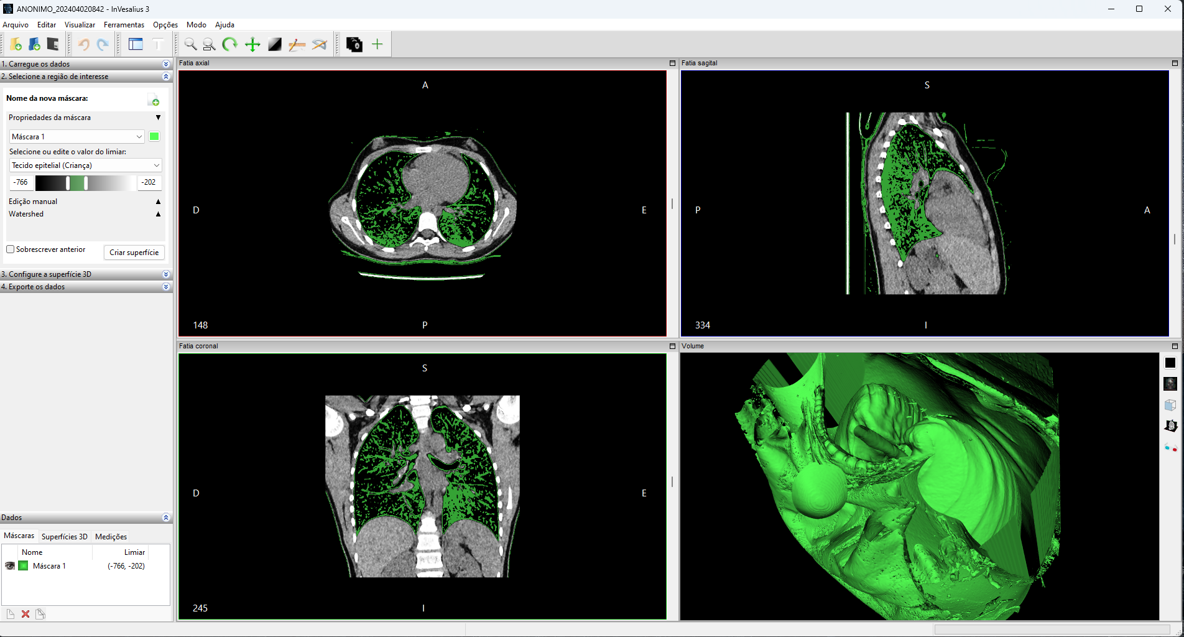
Source: authors themselves, 2026
4. Importing and editing the 3D digital model in Meshmixer software for cleaning, removing unnecessary parts, and reducing the file size
To prepare the 3D digital model, we used the free Meshmixer software, which is capable of opening large, complex 3D model files and offers features for optimizing them. After importing the model, cleaning was performed (Figure 2), removing all unnecessary parts, such as clothing, skin, and other objects captured in the CT scan. Also, one of the biggest challenges when working with 3D digital models from CT scans and Invesalius is the large file size, which can make editing impractical by requiring very high processing power and memory from the computer. Therefore, after cleaning, we sought to reduce the resolution of the generated mesh, in this case by 50%, from 5.2 million to 2.6 million triangular faces. After cleaning and reduction, the model was exported in .stl format to be edited in Rhinoceros 3D software.
Figure 2 - Cleaning the model in Meshmixer software.
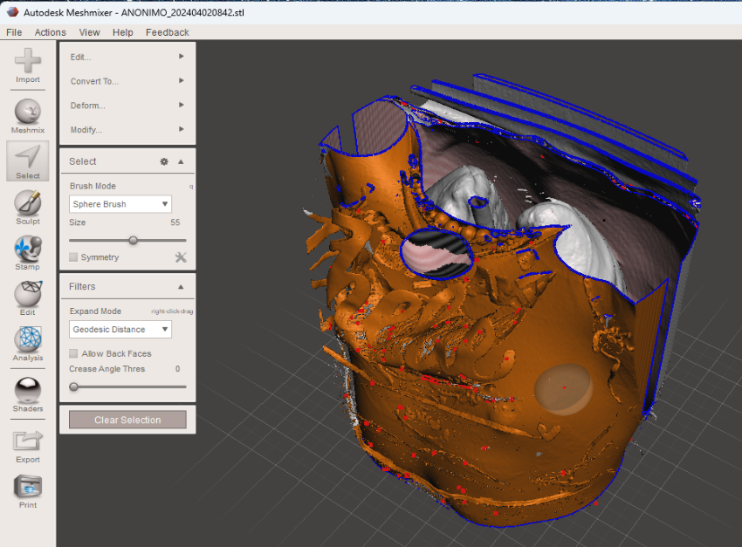
Source: authors themselves, 2026
5. Importing and editing the 3D digital model in Rhinoceros 3D software, including subdivision and export of the model into separate parts
After importing into Rhinoceros 3D software (Figure 3), the 3D model was subdivided (Figure 4) to enable the parts to be printed independently. This strategy was chosen because it was not feasible to print the entire assembly in a single print, given the complexity of the various anatomical elements. Thus, it was decided to print the larger and less complex parts (lungs, trachea, and bronchi) in FDM process with PLA filament, while the more complex and delicate parts (bronchial branches) were printed in DLP with liquid resin. To do this, each part was separated into a specific layer in Rhinoceros and exported in .stl format.
Figure 3 - 3D digital model imported into Rhinoceros 3D software.  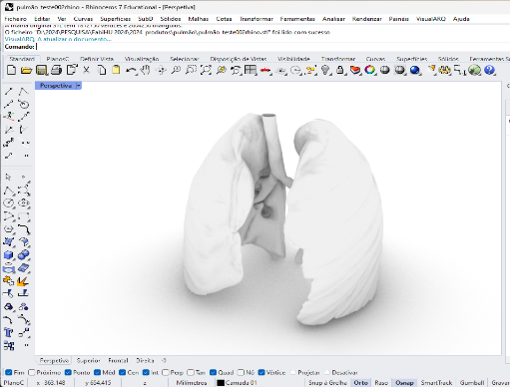 | Figure 4 - The system components, divided into independent parts in Rhinoceros 3D software. 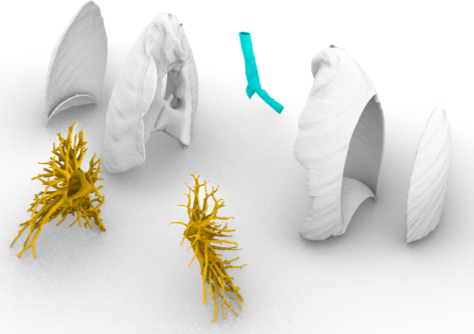
Source: authors themselves, 2026 | Source: authors themselves, 2026
5.1 Part 2: Specific Steps in the FDM Process
After separating the system into independent components, those to be printed using FDM were imported into Ultimaker Cura software to generate the slicing files (G-code), which were then sent to the Ender 5 Plus 3D printer.
1. Importing the trachea and lung components into Ultimaker Cura software and preparing them for 3D printing by slicing the model (G-code)
Different print resolutions were used for each component: 0.2 for the trachea and 0.32 for the lungs. Additionally, for comparative testing, one of the lungs was printed on a machine with a 0.4 mm nozzle, and the other on a machine with a 1mm nozzle. There was no significant difference in quality, but the print simulation using a 1mm nozzle, performed in Cura software, indicated a 23% shorter print time (8h30’, instead of 10h56’) compared to the part printed with a 0.4 mm nozzle, which could result in a significant reduction in print times for larger parts. The goal was thus to optimize printing time without sacrificing the final quality of the part, taking into account the geometric complexity of each one. After the slicing stage (Figure 5), the .gcode file for each component was saved to a USB drive and loaded into an Ender 5 Plus printer to print the part.
Figure 5 - Slicing of the 3D model of the right lung, with printing supports.
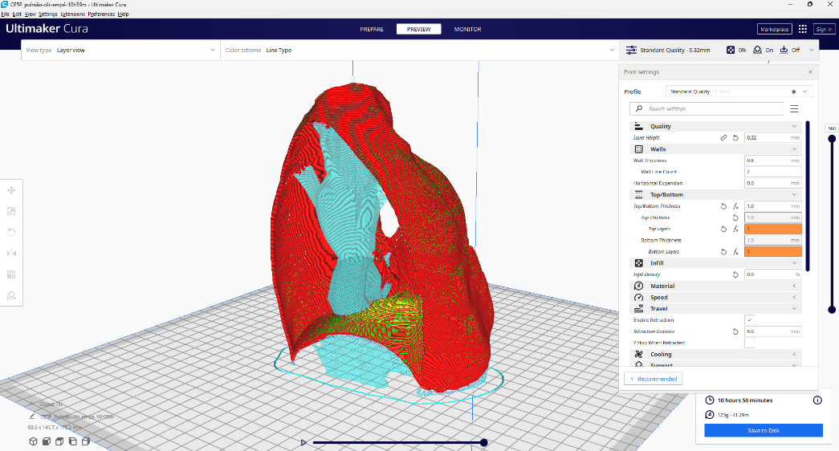
Source: authors themselves, 2026

2. Loading the .gcode file into the FDM 3D printer, 3D printing the trachea and lungs using PLA filament, and removing the supports
The FDM prints were performed on two specific machines, one with a 0.4 mm extruder nozzle (trachea and left lung) and the other with a 1mm nozzle (right lung). The print times estimated by the Cura software were confirmed, indicating better cost-effectiveness when printing with a 1-mm nozzle; the other print settings were maintained, particularly the 0.3-mm resolution, which proved sufficient for printing the lungs (Figure 6). The trachea was printed at a 0.2 mm resolution, resulting in good surface and structural quality, even with a very thin wall of approximately 1.5 mm, and in a reasonable printing time of just 1 hour and 45 minutes. There was a weak point in the print layer, which was reinforced by applying liquid resin (Figure 7) that was then cured in a UV curing unit.
Figure 6 - One of the lungs being printed in gray PLA, with print supports on the bottom and inside. 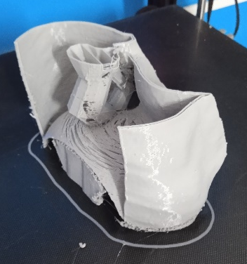 | Figure 7 - One of the printed lungs being covered in resin for layer reinforcement. 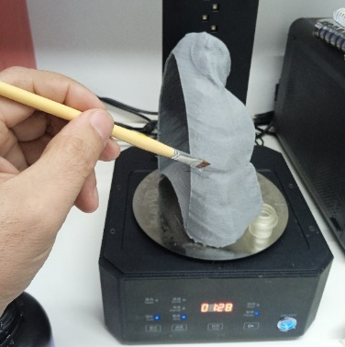
Source: authors themselves, 2026 | Source: authors themselves, 2026
Part 3: Specific Steps in the DLP Process
Just as was done for the FDM-printed parts, after separating the system into independent components, the bronchial branches (bronchioles) that would be printed in liquid resin using the DLP process were imported in STL format into the Halot Box software to generate the G-code files, which would then be sent to the Halot One printer.
1. Importing each of the bronchial components into the Creality Halot Box software and preparing them for printing by slicing the model (G-code)
To print the bronchioles, it was necessary to subdivide the two sets (left and right) into smaller parts due to the volume limitations of the Halot One printer. A layer resolution of 0.1 mm was used, and various positioning methods and support structures were tested until the optimal configuration was found. The estimated printing time for each set of bronchioles was approximately 5 hours. After the slicing stage (Figure 8), the G-code file for each component was saved to a USB drive and loaded into a Halot One printer for printing.
Figure 8 - Slicing of one of the bronchial sets, with the printing supports.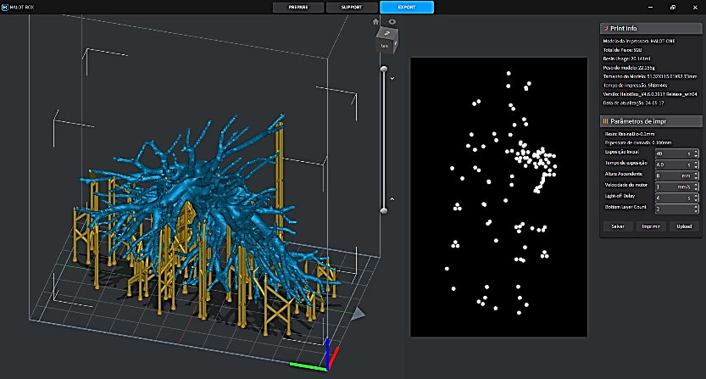
Source: authors themselves, 2026

2. Loading the G-code file into the DLP 3D printer (liquid resin), 3D printing of the bronchi, removal of supports, washing with alcohol, and UV curing
The resin prints were performed simultaneously on two machines (Figure 9), one for each set of bronchioles (left and right), which enabled faster printing of the set. Liquid crystal resin was used on both, and the print times estimated by the Halot Box software were confirmed. After printing, the parts were removed from the printing platform (Figure 10), the printing supports were removed, and each part was washed with isopropyl alcohol to remove excess resin. The parts were then cured in a UV curing machine.
Figure 9 - Parts of the bronchioles being printed simultaneously on two resin printers. 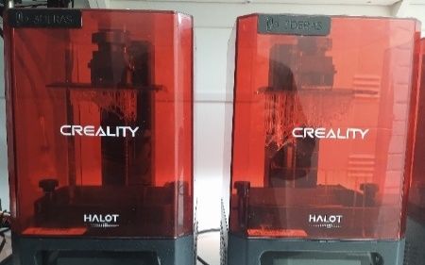 | Figure 10 - One of the printed assemblies, with the supports still fixed to the printing platform. 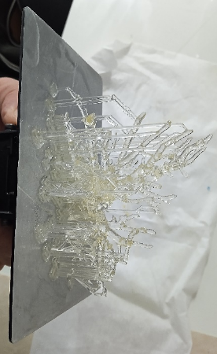
Source: authors themselves, 2026 | Source: authors themselves, 2026
Part 4: Assembly of the Model
After printing all the parts in PLA and liquid resin, the model was assembled. First, the trachea (Figure 11) and the two lungs were joined by applying liquid resin to the contact surfaces, which was then cured in the UV curing machine (Figure 12). After assembling this component, we began assembling the resin-printed bronchi inside each lung (Figure 13). The assembly was completed by attaching the side covers of the lungs (Figure 14), which are fixed to the device by means of three magnets on each side. These were joined to the device using high-adhesion glue and liquid resin cured in the UV machine. The covers serve to facilitate visualization of the internal parts of the lungs, thereby enhancing educational use.

Figure 11 - Joining of the trachea and one of the lungs using liquid resin. 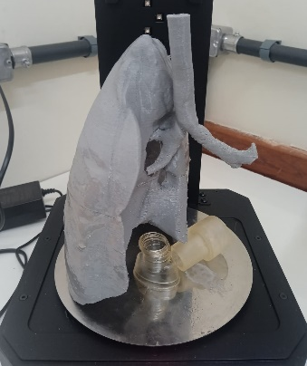 | Figure 12 - Curing joints in a UV machine. 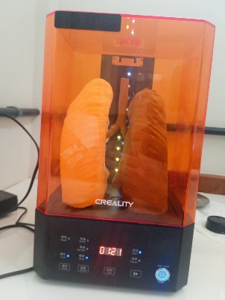
Source: authors themselves, 2026 | Source: authors themselves, 2026
Figure 13 - A bronchioles set assembled in one of the lungs. 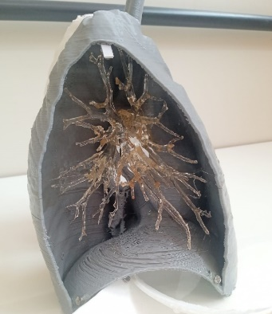 | Figure 14 - Final assembly with the side covers secured by magnets. 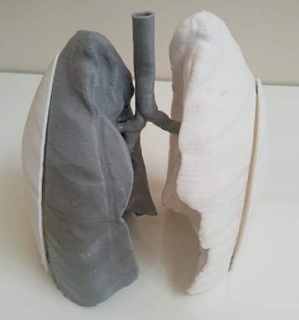
Source: authors themselves, 2026 | Source: authors themselves, 2026
4.5 Classroom Use
The biomodel was used in the classroom (Figure 15) in the Pediatric and Neonatal Physical Therapy course for third-year students in the Physical Therapy program at UEL. The aim of having the biomodel complement the theoretical foundation in the classroom and also to give students the opportunity to visualize and handle life-size anatomical structures: the trachea, the two lungs, the bronchi, and the internal branches of the bronchioles. Using this biomodel, it was hoped that students would correlate, through logical reasoning, theoretical knowledge with the clinical practice of physical therapy. This objective was accomplished, with one student commenting: “Upon observing the reduced diameter of the bronchial branches, I understood why even a small accumulation of secretions in these passages leads to early respiratory distress in this child,” reinforcing the importance of the physical therapist’s role in this population.
Figure 15 - The biomodel being used in a class with physical therapy students.
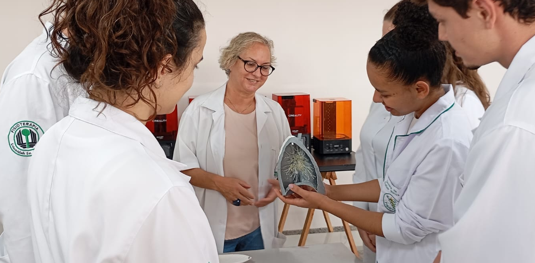
Source: authors themselves, 2026

The use of contrast between the lung (gray) and the bronchi (crystal resin) proved to be more functional than in the case of the lung rendered in white. Two aspects that need improvement are: the fixation of the trachea to the lungs, as frequent handling caused one of the parts to detach; and the thickness of the lung walls, which made it difficult to attach the magnets.

4 - RESULTS AND DISCUSSION
The following section discusses the technical and sustainability aspects of the process used to create the biomodel described above.
4.1 Technical Aspects
Due to the need for data processing throughout the process, it is recommended to use a computer with sufficient memory (at least 16 GB) and processing power, preferably with a dedicated graphics card (minimum 2 GB) to speed up image processing and avoid bottlenecks during editing.
Generating the 3D digital model from the CT scan proved relatively simple, provided there is prior training in the use of the Invesalius software. Optimizing the generated 3D mesh is an essential step, as it made editing the model in Rhinoceros software more agile and fluid. The ability of the professional responsible for the process to navigate efficiently between different software programs is one of the most important factors for creating 3D biomodels, just as important as the ability to use different types of 3D printers, whether FDM or DLP.
In the FDM printing it was found that two variables that directly affect print time are nozzle diameter and layer resolution. In the case of liquid resin printing (DLP), it was found that it may be necessary to divide a part into smaller sections due to the size limitations of the print volume. However, this problem can be solved by using printers with greater capacity, which are currently available on the market at affordable prices. For resin printing, a layer resolution of 0.1 mm proved sufficient to achieve the desired details.
Removing supports and washing the parts proved to be one of the most time-consuming steps, as did assembling and bonding the parts using the resin itself through successive UV curing stages. This is a delicate process that requires considerable patience and care from the professional to avoid damaging the parts and achieve a satisfactory result. This also applies to the placement of magnets to secure the side parts using high-adhesion glue. Additionally, repairs may be necessary if any part comes loose, which occurred during the usage phase when the trachea piece detached from the lung piece.
4.2 Environmental Sustainability Issues
The main environmental concerns related to 3D printing of biomodels pertain to the liquid resin printing process, as the resin is a thermosetting material that cannot be recycled after curing. Special care must be taken when disposing of resins, which must always be cured to a solid state and then carefully separated for disposal as general waste. Washing with isopropyl alcohol also poses an environmental problem, and an alternative to reduce the environmental impact in this case is the use of water-washable resins. The FDM filaments used in this study are made of recyclable PLA and can be disposed of more safely or melted down and re-extruded, provided the necessary conditions are met.
4.3 Aspects of Social Sustainability
It is worth noting here that this biomodel was developed at a public teaching hospital, as the learning gains achieved by the students can result in improved care for patients at the hospital itself, which is 100% public as it is part of the SUS system. With expanded access to physical teaching biomodels, students can use them whenever necessary. There are also scientific and technical learning gains for students who work as researchers in the laboratory, as they expand their skills significantly beyond those developed in their original degree programs.
4.4 Aspects of economic sustainability
From an economic standpoint, it is worth noting that in-house production of biomodels can lead to cost savings for the hospital and the university, given the high cost of 3D teaching materials. Added to this is the difficulty in acquiring these materials, typically through bidding processes that are often time-consuming, unpredictable, and costly. Considering that the cost of setting up and operating 3D printing labs in hospitals is currently quite feasible—a lab meeting the requirements outlined in this article can be established for approximately R$ 30,000—on-site printing of biomodels becomes a viable option for Brazilian public teaching hospitals. The equipment, supplies, and software used for the process represent a relatively low cost, considering the value delivered throughout their lifecycle to patients, professionals, and the institution.
5 - FINAL CONSIDERATIONS
The use of combined 3D printing techniques has proven to be a valuable resource for the production of biomodels for educational purposes. The technical aspects point to a viable process, and the recommendations presented in this article, as well as the limitations encountered, aim to ensure this viability for use in laboratories at public hospitals, such as HU UEL. The biomodel resulting from this study proved useful for classroom instruction, facilitating students’ learning regarding the anatomical and physiological aspects of the organ under study. In this regard, fragility is one of the points to be addressed in future applications. Finally, it was found that, although 3D printing of biomodels offers significant social and economic benefits, it also presents environmental challenges regarding the end of the materials’ life cycle, particularly UV resins. These challenges should be addressed through new studies to be conducted at Fab.i HU.

BIBLIOGRAPHIC REFERENCES
Aguiar, L. D. C. D. (2016). Um Processo Para Utilizar A Tecnologia De Impressão 3d Na Construção De Instrumentos didáticos para o ensino de ciências. Journal of Chemical Information and Modeling, 6 (2), 1689–1699. Disponível em < http://hdl.handle.net/11449/137894> acesso em 01 fev. 2025.
Balestrini, C., & Campo-Celaya, T. (2016). With the advent of domestic 3-dimensional (3D) printers and their associated reduced cost, is it now time for every medical school to have their own 3D printer? Medical teacher, 38(3), 312–313. Disponível em < https://doi.org/10.3109/0142159X.2015.1060305> acesso em 01 fev. 2025.
Barbosa, J.B.M; Mendonça, F.J.S. DE F.; Tavares, F.R.M.; Figueredo, J.F.de S.; Leite, M.J.F. Utilização de impressoras 3D para o desenvolvimento de metodologias ativas em cursos de Engenharia. Research, Society and Development, v. 10, p. e181101018657, 2021.Disponível em < https://rsdjournal.org/index.php/rsd/article/download/18657/16719/231695> acesso em 01 fev. 2025.
Garcia, T.R., Macedo, R.M.; Vieira Vaz, M.H., Borges, G.H.J., Zendron, I.M., Arruda, J.T. Impressão 3D de peças anatômicas como ferramentas de educação e auxílio na prática clínica. Research, Society and Development, v. 11, n. 13, e248111335234, 2022 (CC BY 4.0) | ISSN 2525-3409 | DOI: http://dx.doi.org/10.33448/rsd-v11i13.35234. Disponível em: <https://www.academia.edu/117649154/Impress%C3%A3o_3D_de_pe%C3%A7as_anat%C3%B4micas_como_ferramentas_de_educa%C3%A7%C3%A3o_e_aux%C3%ADlio_na_pr%C3%A1tica_cl%C3%ADnica>. Acesso em: 9 fev. 2025.
Louredo, L. M. ; Duarte, M. M. S. ; Araujo, M. C. E. ; Moreira, S. M. ; Sugita, D. M. ; Arruda, J. T. . Aplicabilidade de biomodelos tridimensionais produzidos com impressora 3D para estudos de anatomia. In: I Congresso dos Acadêmicos de Medicina do Estado de Goiás (CAMEG), 2019, Anápolis. ANAIS I CAMEG. Anápolis: RESU ? Revista Educação em Saúde, 2019. v. 7. p. 10-10. Disponível em < https://periodicos.unievangelica.edu.br/index.php/educacaoemsaude/article/view/4187> Acesso em 09 fev. 2025.
Onisaki, H. H. C., & Vieira, R. M.B. (2019). Impressão 3D e o desenvolvimento de produtos educacionais. Revista de Estudos e Pesquisas sobre Ensino Tecnológico (EDUCITEC), 5 (10), 128–137. Disponível em <https://doi.org/10.31417/educitec.v5i10.638> Acesso em 01 fev. 2025.
Orlando, T. C. et al. (2009). Planejamento, montagem e aplicação de modelos didáticos para abordagem de biologia celular e molecular no ensino médio por graduandos de ciências biológicas. Revista Brasileira de ensino de bioquímica e biologia molecular, 2 (1), 2-17. https://doi.org/10.16923/reb.v7i1.33. Disponível em <https://www.bioquimica.org.br/index.php/REB/article/view/33/29> Acesso em 01 fev 2025.
Suárez-Escudero, J. C., Posada-Jurado, M. C., Bedoya-Muñoz, L. J., Urbina-Sánchez, A. J., Ferreira-Morales, J. L., & Bohórquez-Gutiérrez, C. A. (2020). Ensenar y aprender anatomia: Modelos pedagogicos, historia, presente y tendencias. Acta Médica Colombiana,45(4). (PDF) A utilização de biomodelos em 3D no aprendizado da anatomia humana: uma experiência técnica e metodológica. Disponível em <https://www.researchgate.net/publication/364975052_A_utilizacao_de_biomodelos_em_3D_no_aprendizado_da_anatomia_humana_uma_experiencia_tecnica_e_metodologica> Acesso em 09 fev. 2025



